Project Software Engineering
Development of a weather station

Danny Drogt: 408374
Mirsolav Gechev: 429556
Soner Gümüş: 436973
Kristina Prusinskaite: 442028
Stephan Hiddink: 402858

Introduction
During the second year of ACS the students are expected to create a weather station. The subject will be graded for 6 ec’s. The project will follow scrum for structure and planning. The clients are Mr. Slot and Mr. Tangelder. The main part of the project is getting familiar with putting together different subjects which have been learned in the past into one project. These subjects are datastructures, databases, programming 1, programming 2 and software engineering. At the end of the project the team has a complete weather station with a gui, a user manual and other project documentation.

Preface
LoRa is a long range data transmitter used for the TTN (The Things Network). This network is used to let things communicate to the internet (hence the name, The Things Network) without the use of 3G or WiFi. A weather station will be connected to this network to measure several atmospheric values. Values included are: humidity, temperature, pressure and wind speed. Values are displayed in a GUI (Graphical User Interface). The LoRa will connect to the TTN by using the MQTT protocol. The device which will be used is the LoPy. This device contains the sensors to measure the required values. The LoPy is able to connect automatically to the LoRa. LoRa has a duty cycle of 1% so it is imperative that data sending is efficient and small. Data will be stored in an SQL database. This database will be connected by using JDBC. In week 2.7 it is expected that a complete weather station is delivered with a database, a GUI and LoRa/TTN connectivity.

Agreements and Commitments
The team will has decided to use indentation style as the style they will follow. An example of the different coding styles of indentation can be found below. Indentation style could look like this:
if (hours < 24 && minutes < 60 && seconds < 60) {
return true;
} else {
return false;
}
or
if (hours < 24 && minutes < 60 && seconds < 60)
{
return true;
}
else
{
return false;
}
or
if ( hours < 24
&& minutes < 60
&& seconds < 60
)
{return true
;} else
{return false
;}

We as a group will follow the first example of the indentation coding style.

For the different tasks a certain amount of points have been declared aswell as the definition of done. The amount of points should indicate how much time a certain task will cost. For example, a task of two points will cost one full day while a task of six points takes three days to cover. A task may be considered done when it meets the definition of done. The table below defines all the tasks that are going to be done in the first sprint.

Description of task | Amount of points | Definition of done
Lopy-LoRa research | 3 | A sufficient – good understanding of the modules
LoPy connectivity to database | 5 | A working data connection between the two components
Research LoPy sensors | 2 | An understanding of the functionality and implementation of the sensors
Program the sensors | 3 | The four sensors, humidity, light, pressure and temperature are able to receive data and show it in an understandable way
TTN research | 4 | Understand the idea and use of TTN
Understand and implement MQTT broker | 5 | Protocol broker is implemented and can function as a bridge between the device and the ttn
Connect LoRa to TTN | 3 | A working data connection between LoRa and TTN
GUI: determine display data | ½ | Group and client agrees on data which need to be displayed
GUI: implement data and graphs | 7 | Gui is able to hold and visually show the data in an understandable way
GUI: connectivity with database | 1 | GUI can read data from the database
GUI: complete interface | 6 | User interface which is easy to use and read for the client
SQL: create the database | 1 | Data can be stored in the SQL database
SQL: implement JBDC | 4 | A sensible connection has been created

Burndown week 1-2
Here below a burndown chart can be found. As seen not all tasks where able to be completed. It might be wise to do less tasks in a certain sprint. The points declared for each task in respect to the amount of hours in the first sprint was also out of proportion. Meaning that there were more points in one sprint than that there was time available.

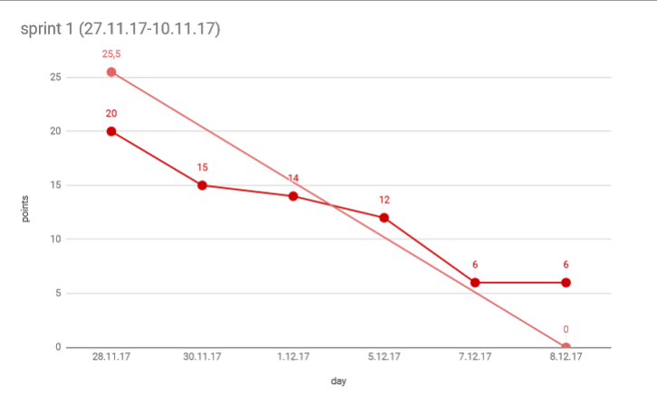

Retrospective: week 1-2
After each 2 weeks a retrospective is made. Below can be found the retrospective of week 1 and 2. The retrospective is defined in what went well and what could be improved.
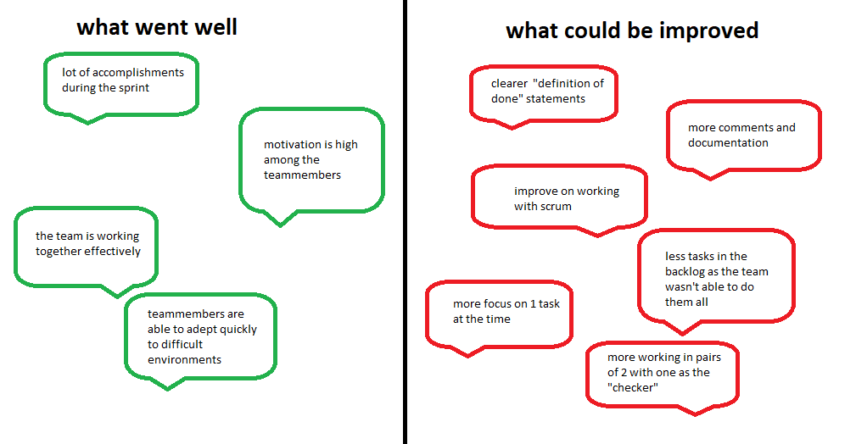

Burndown week 3-4
Here below a burndown chart can be found. All tasks were finished during this sprint. It is interesting to see that approximetly the same amount of points have been calculated and burned as the previous sprint. The team might have a good estimation of how hard certain tasks are. Below the burndown chart of week 3 and 4 can be found.
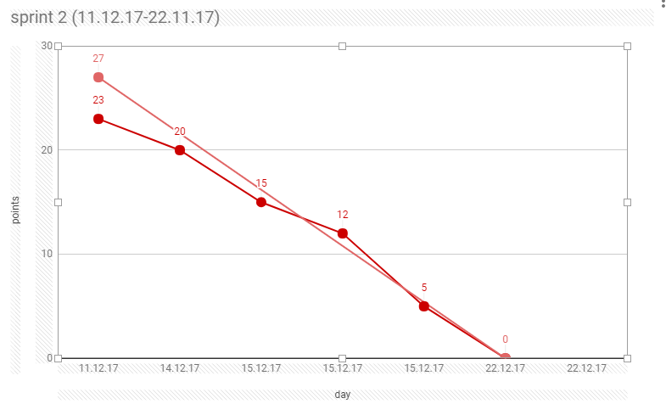

Retrospective: week 3-4
During the sprint of week 3 and 4 the team needed to change the backlog of trello. In the appendix the updated backlog can be found while in the chapter Agreements and Commitments the original backlog is available. This way it is possible to track the team’s progress. Another retrospective has been made for week 3 and 4.
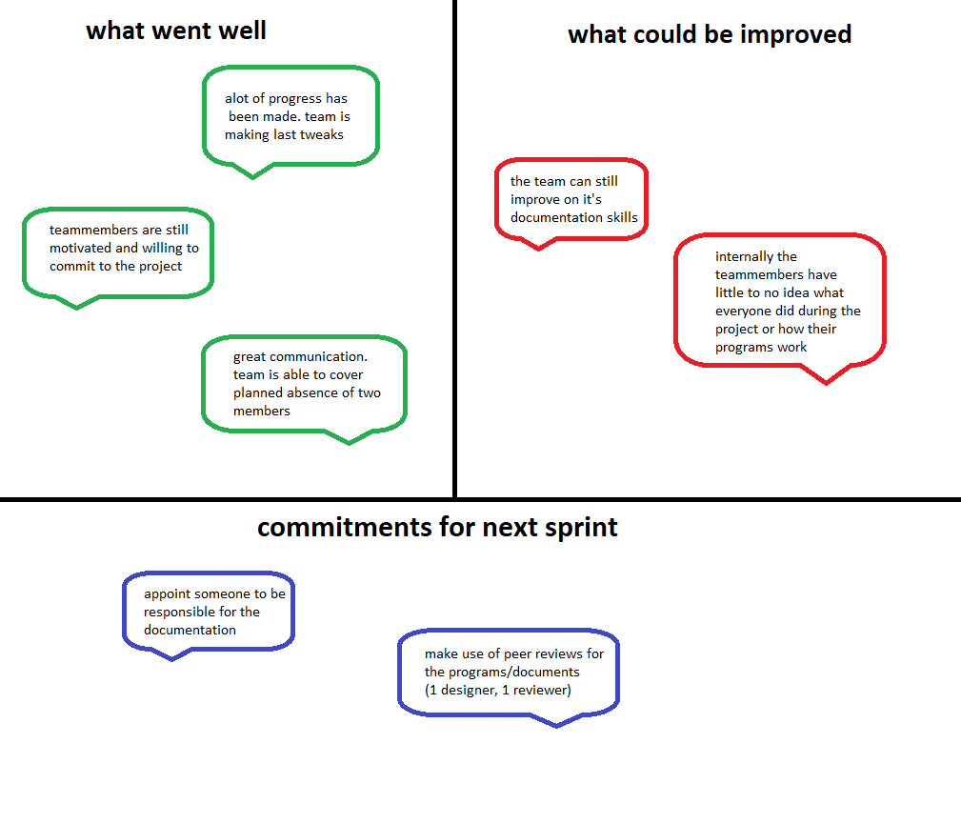

Appendix

Description of task | Amount of points | Definition of done
Lopy-LoRa research | 3 | A sufficient – good understanding of the modules
Connect Lopy to LoRa | 4 | The Lopy is able to send data to the LoRa
TTN connection to database | 5 | A working data connection between the two components
Research LoPy sensors | 2 | An understanding of the functionality and implementation of the sensors
Program the sensors | 3 | The four sensors, humidity, light, pressure and temperature are able to receive data and show it in an understandable way
TTN research | 4 | Understand the idea and use of TTN
Understand and implement MQTT broker | 5 | Protocol broker is implemented and can function as a bridge between the device and the ttn
Connect LoRa to TTN | 3 | A working data connection between LoRa and TTN
GUI: determine display data | ½ | Group and client agrees on data which need to be displayed
GUI: implement data and graphs | 7 | Gui is able to hold and visually show the data in an understandable way
GUI: connectivity with database | 1 | GUI can read data from the database
GUI: interface | 6 | User interface which is easy to use and read for the client
GUI: testing | 8 | Use the gui in a use case scenario to determine if there are any bugs
SQL: create the database | 1 | Data can be stored in the SQL database
SQL: implement JBDC | 4 | A connection has been created to TTN
Create an App/website (optional) | 10 | Have access to a website/app that hosts all the data and has a user control interface
Final report | 6 | Full written report about the activities of the report

